Department of Computer Science and Engineering
A
Final Examination Fall 2022
CSE 321: Operating Systems
Duration: 2 Hours | Total Marks: 40
Answer the following questions.
Figures in the right margin indicate marks.

1.  CO4 | a) A system has processes to execute of which 50% is parallel. If the number of cores is increased from 1 to 4, what will be the increase in performance?  b) Distinguish between many-to-many and many-to-one multithreading models. | [2]  [2]
2.  CO5 | a) Suppose a faculty member can take a maximum of 5 groups of students for doing a thesis under him in a semester. In a particular semester, a total of 9 groups applied for doing a thesis under his supervision. Among them, he selected 5 groups and kept the rest of the other groups on a waiting list for the next semester where groups will be selected according to a first come first serve manner from the waiting list if any of his slots gets free. Logically explain which synchronization method has been used here.  b) For Peterson’s problem below conditions will be applied.  - There are two processes: P1 and P2.  - Each Statement takes 3ms to execute.  - Context Switch will occur after 9ms.  - Both the Critical & Remainder section contains 3 statements.  - For P1: i=0 and j=1  - For P2: i=1 and j=0  - turn=0  - flag[0] = FALSE, flag[1] = TRUE  The structure of process P_{i} in Peterson’s solution:  do{  flag[i] = true;  turn = j;  while(flag[j] == true && turn == 1){  //busy wait  }  //critical section  flag[i] = false;  //remainder section  }while(true);  Complete the table given below for processes P1 and P2 using Peterson’s solution.  Process 1: i=0, j=1 Process 2: i=1, j=0 | [2]  [4]
3.  CO5 | a) Consider the following snapshot of a system:  Allocation MAX  A B C D A B C D  P0 5 1 1 4 10 5 10 5  P1 2 2 6 2 5 9 10 3  P2 2 8 6 4 9 12 9 10  P3 4 6 8 2 4 6 8 3  Available  1 1 0 3  - Is the system in a safe state? Apply Banker’s safety algorithm to find out the safe sequence. You need to calculate the need matrix.  - P₁ requests for (1 0 0 1). Check the validity of the request. If the request is valid, does the system enter a deadlock?  b) Suppose, in an office, we have a set of resource types, R = {R1, R2, R3} and a set of processes, P = {P1, P2, P3, P4, P5}. R1, R2, and R3 have 3, 2, and 1 instance respectively.  - P1 requests for 1 instance of R3  - P1 is holding 2 instances of R2  - P2 requests for 1 instance of R2  - P2 is holding 1 instance of R1  - P3 is holding 1 instance of R3  - P3 requests 1 instance of R1  - P4 is holding 1 instance of R1  - P5 is holding 1 instance of R1  - P5 requests 1 instance of R2  Construct a resource allocation graph for the above scenario. Mention the number of cycles found and identify whether there is a deadlock or not. | [4]  [2+3]  [3]
4.  CO6 | a) At a particular time, the snapshot of the Main memory is given below for dynamic partitioning where gray portions of the memory represent occupied spaces. Apply worst fit and first fit algorithms to place processes with the space requirement of P1=300k, P2=200k, P3=149k, P4=146k, P5=100k, P6= 50k, P7=22k and P8=29k (in order). Explain which algorithm makes the most effective use of memory.  b) Assume that the page size is 3 bytes and the Physical Memory size is 36 bytes. Show the users’ view of memory which is mapped into physical memory.  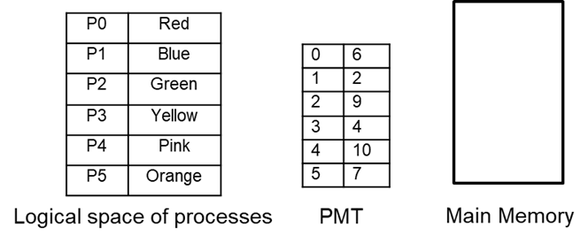  c) If the page size is 2 KB, how many frames will be needed in Main memory for a process size of 38,767 Bytes? Is there any internal fragmentation? - If yes, calculate the value. [1 KB = 1024 Bytes] | [2+2+1]  [2]  [2]
 | d) What are the differences between static and dynamic techniques for partitioning main memory? | [3]
5.  CO6 | Consider a computer with a main memory that has 3 frames and page reference string of 0-7 pages: [7 0 6 4 2 6 1 2 0 5 1]. The page reference string represents the order in which the pages are accessed by a program. Apply FIFO & LRU algorithm to simulate the page replacement that occurs when the main memory can hold at most 3 pages at a time. Record the number of page faults and compare the result. Mention which algorithm performs better in this scenario. | [4+1+1]

